Problem Statement:

1. You have to create a linear regression model in Python or R to predict the CTC/Salary of new hires from the data provided.
2. Your task is to help John from STA IT services to create a linear regression model in Python or R to predict the CTC/Salary of new hires from the data provided. Here is a snapshot of the case.

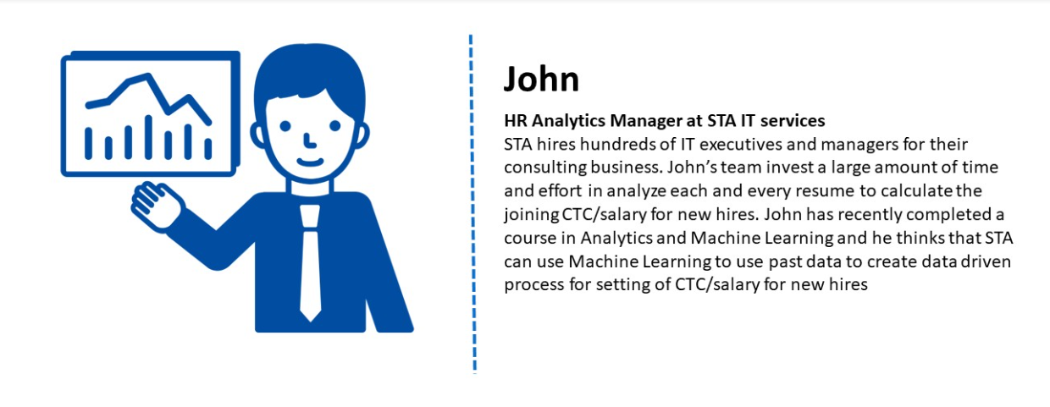

Your task is to

1. Understand the data
2. Transform categorical variables to the numerical variables
3. Apply linear regression to predict the CTC
4. Evaluate the results of the analysis